**RESUME**

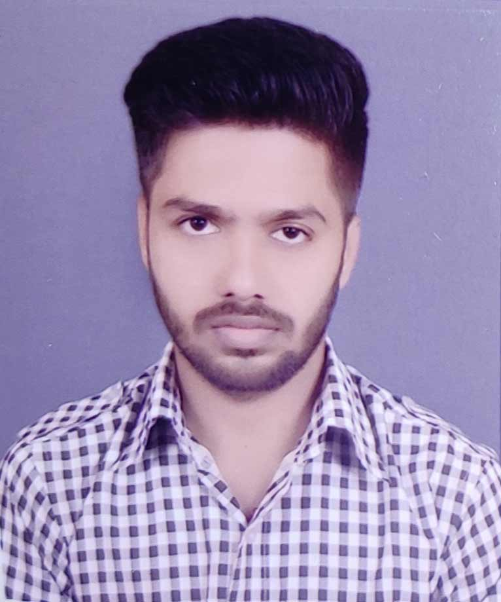

PHOTO

**AMARJEET VISHWAKARMA**

**Address :-** Rastriya Ganj , Phulwari Sharif , Patna , Bihar 801505

**Mobile No. :-** 7677621374

**Email ID :-** [amarjeetvishwakarma2901@gmail.com](mailto:amarjeetvishwakarma2901@gmail.com)

**CARRIER OBJECTIVES**

To seek a dynamic and challenging career an organization strives for excellence with my knowledge and team effort while making positive contribution to promote the individual opportunity and professional growth.

**ACADEMIC QUALIFICATION**

|  |  |  |  |  |
| --- | --- | --- | --- | --- |
| Sr. No. | **Class/ Degree** | **Board/University** | **Year** | **Division /Percentage** |
| 1. | Matriculation | CBSE | 2016 | 1ST / 74% |
| 2. | Intermediate | BSEB | 2019 | 1ST / 61% |
| 3. | Graduation(BCA) | PatliPutra University | 2022 | 1ST / 63% |

**TECHNICAL QUALIFICATION**

|  |
| --- |
| Advance Diploma In Computer Application (ADCA), 1st ,2018 |

**PERSONAL DETAILS**

**Father Name :-** Dina Nath Vishwakarma

**Mother Name :-** Nilu Devi

**Date of Birth :**- 02/09/2001

**Gender :**- Male

**Marital Status :**- Unmarried

**Nationality :**- Indian

**Religion :**- Hindu

**Language Knowledge :**- Hindi & English

**AREA OF EXPERTISE**

MS Word , MS Excel , MS Powerpoint , Photoshop ,

Canva , Basic Programming

Team work

**DECLARATION:-**

*“I hereby declare that the above particulars of facts and information stated are true, correct and complete to the best of my belief and knowledge.”*

Date:-

Place:- Amarjeet Vishwakarma